Our GPU driver has already implemented those OpenGL function, what we need to do is to pull out those function, use the pointer to call them. Instead of using win32 to load those function, we will use some tool to help us do that. Because for different platforms, it will have different function pointer with different location, and those tools will help us locate those pointers by its platform.

We will use GLEW at this course

There is a problem you may encounter if you don’t read the manual. You need to create a context before you use GLEW

First, download GLEW, and add it to our project like glfw

We add glewInit() here below glfwInit()

And we will get:



Why?

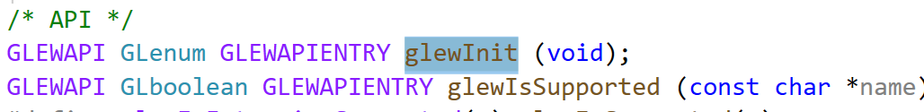

We check the glewInit function, and we find that this function return GLenum type, and input is void. It also has a prefix called GLEWAPI. We check this prefix:

It says that if we define GLEW_STATIC (use static .lib file, instead of .dll file), then GLEWAPI define as extern. If we use .dll library, then GLEWAPI is equal to “extern _declspec(dllexport)”

Right now we don’t have GLEW_STATIC define and GLEW_BUILD, it will go to the final line. Now we are not using the dll version of GLEW. What we need to do is to define GLEW_STATIC by ourself.

We add a preprocessor

But we find that it is not okay. Because remember we need to create a context. So we put it over here.

When we call a function:

It is actually macro define

When we go to _glewGenBuffers

When we go to the type of this function



Return void, take size and unsigned int

We get the version:

